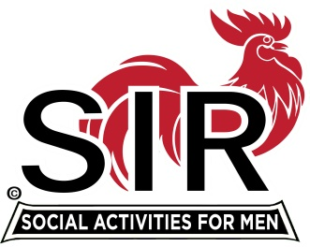
Las Trampas Branch 116
Meeting Agenda
June. 2020, 11:45 AM
The Mission of SIR is to enhance the lives of our members through fun activities, events and luncheons – while making friends for life

11:45 Social Time

12:00 BIG Sir: Welcome

12:05 Little SIR: Introduction of Speaker followed by Q & A

12:40 Little SIR: Speaker “Thanks.’

12:45 Activities: Fred Wachowicz
Bernie Wroblewski

1:00 Little SIR: Birthday Boys

1:05 Big Sir: Close Meeting

